Name : Saurabh Sanjay Jadhav

Topic : Attach EFS volume to 3 instances.

Assignment no. : 22

1. Create 3 EC2 instances with similar configuration.

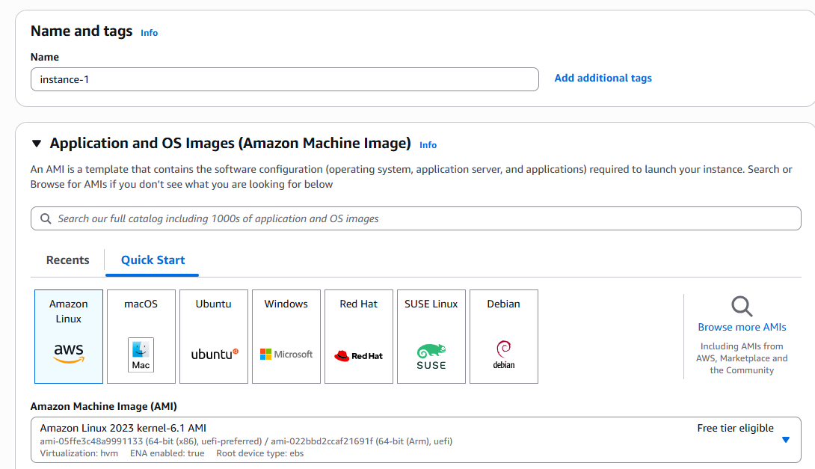

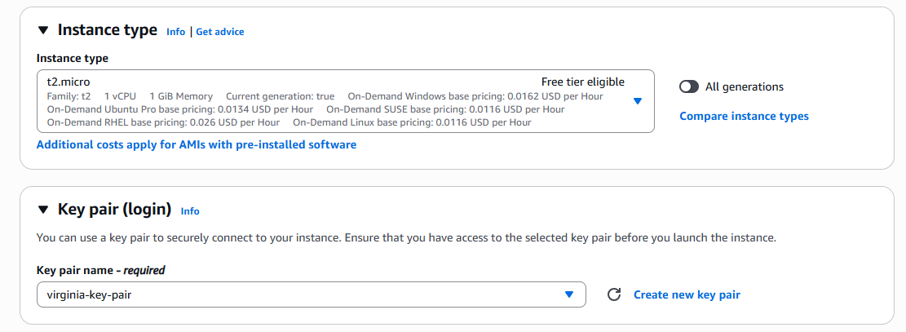

Select different AZ for each instance.

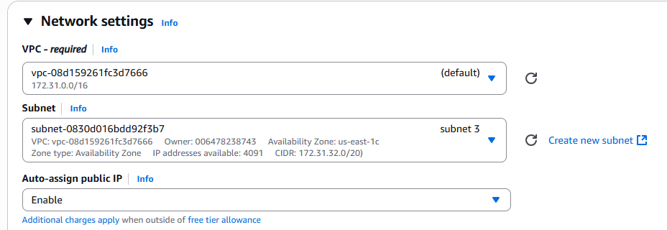

Create new security group – Add inbound rule to allow NFS (2049) port.

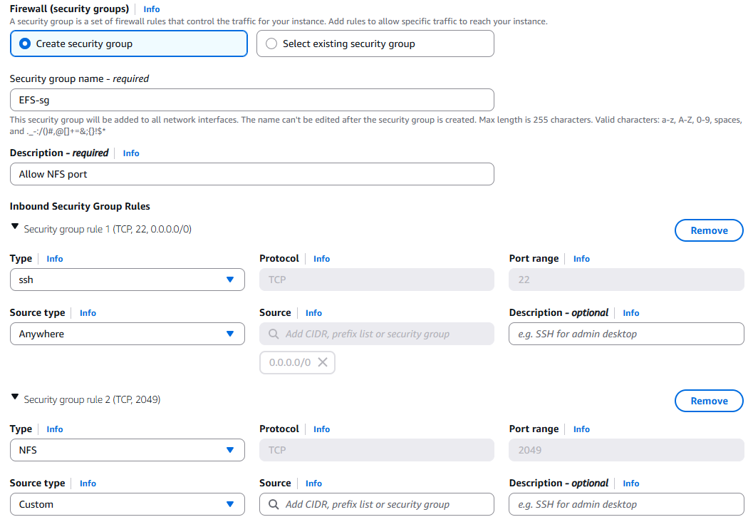

1. Create EFS

Name : Saurabh-efs and select the default vpc. Click on customize.

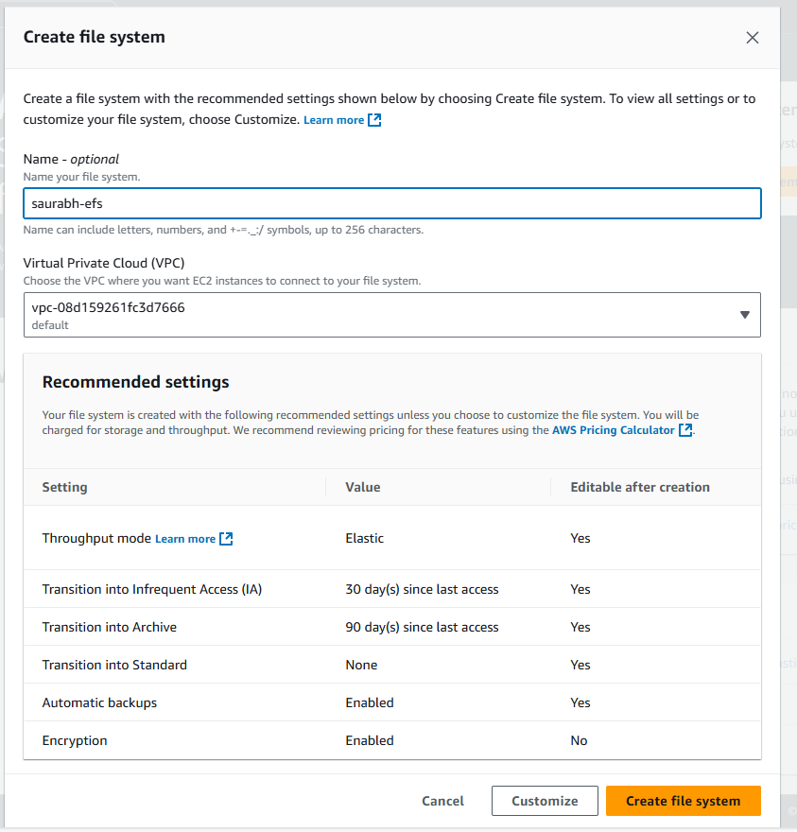

1. Select file system as regional.

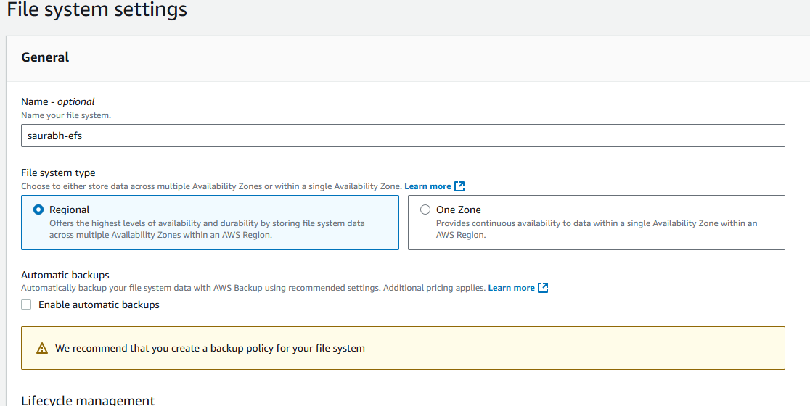

1. Configure the lifecycle management.

Transition to infrequent access : 30days

Transition to Archive : 90days

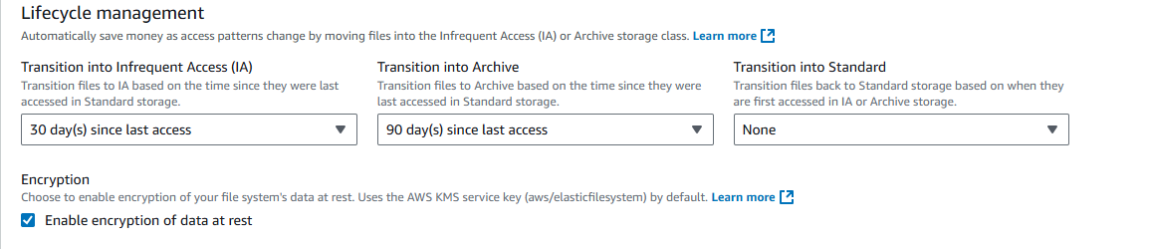

1. Performance setting.

Select enhanced and elastic.

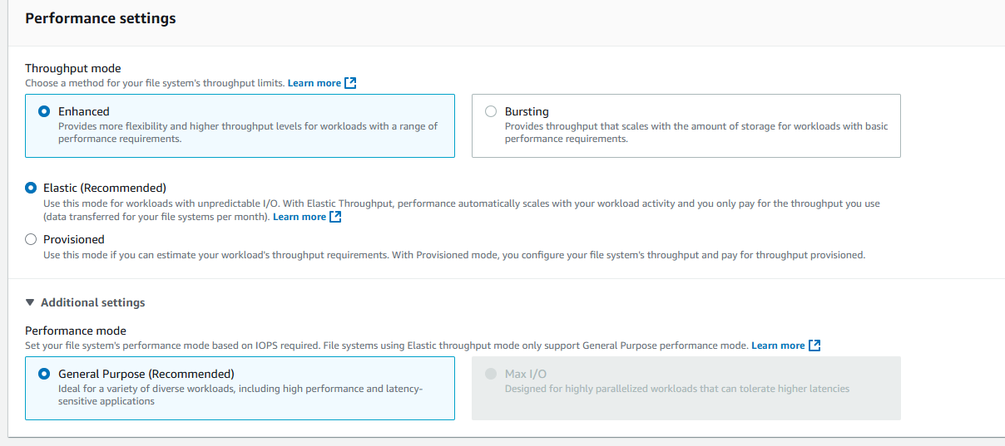

1. Network access setting.

Select the VPC and security group that you have mentioned in EC2 instance.

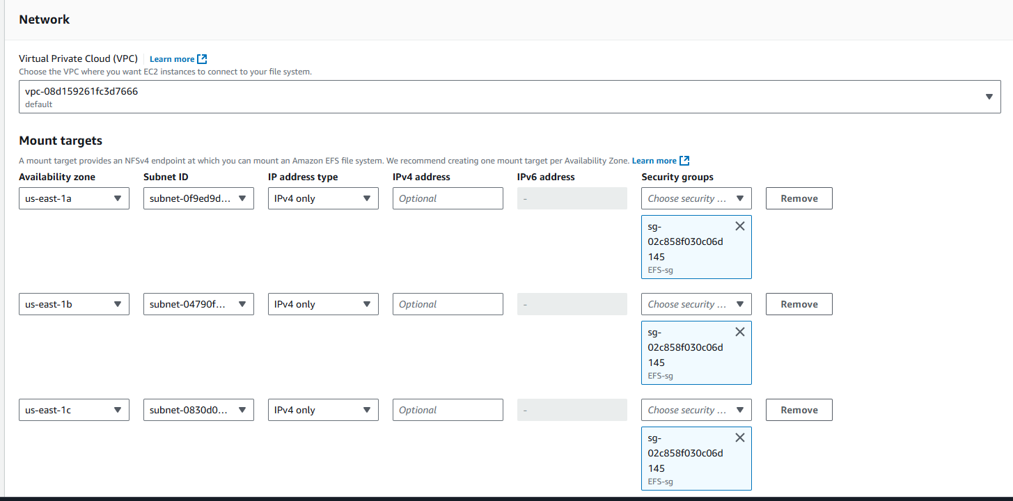

1. We can create file system policy.

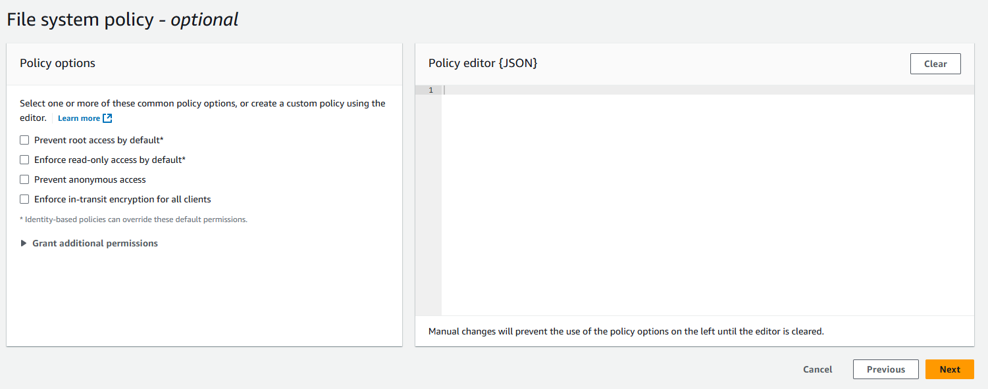

1. Successfully created EFS.

1. Configure EC2 instance EFS storage.
2. Install amazon efs.

Yum install -y amazon-efs-utils

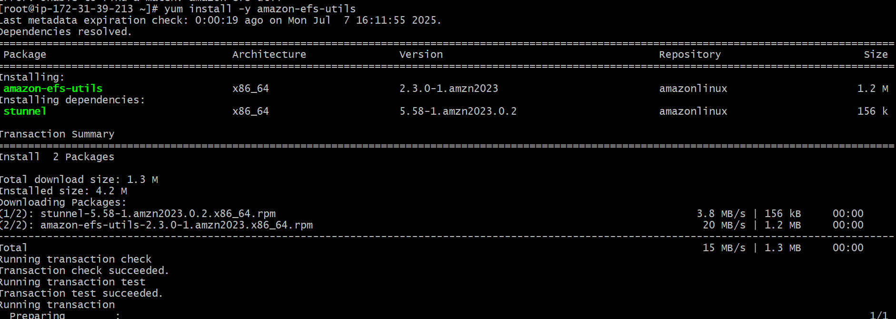

1. Mount the efs storage to efs1 directory.

sudo mount -t efs -o tls fs-07527835d1015b00a:/ efs1

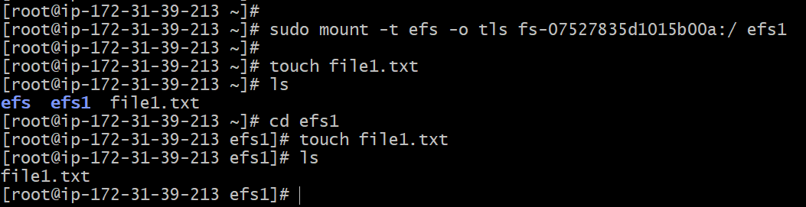

10.

a. created file from Instance-2 in efs storage.

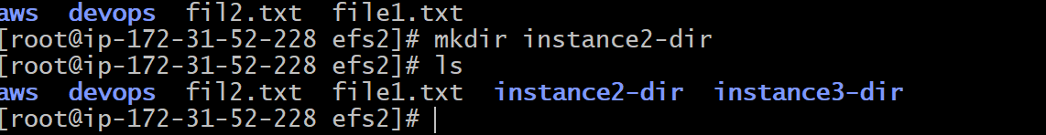

1. Created file from instance-3 in efs storage.

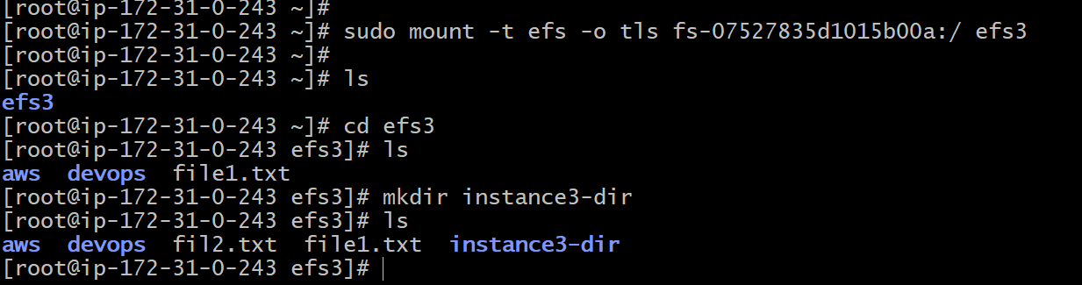

1. Created file from instance-1 in efs storage.

